Driving Rehabilitation Services

Stan Cassidy Centre for Rehabilitation  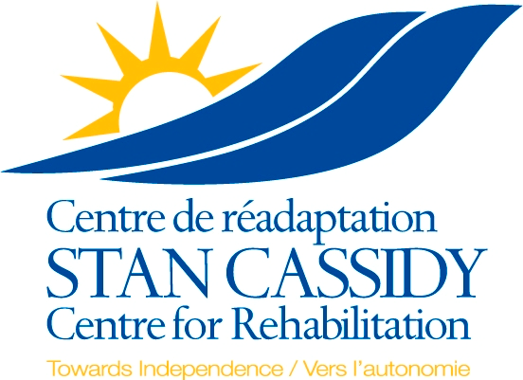  800 Priestman Street  Fredericton, N.B  E3B 0C7  Ph: (506)447-4214  Fax#: (506)447-4160  Language Preferred: Is patient:  English WorkSafe  French DVA  Other: ______________ Other_____________  Family/patient is aware of referral | Name of Patient:  Address (home):  Telephone: (home) Cell:  Email address: _______________________________________________  Medicare: Exp. Date:  Date of Birth: ________ ________ ________  dd mm yy

Driving Assessment
Vehicle Modification Consultation (Passenger only)
New Learner Driver

DATE OF DIAGNOSIS: ____________

DIAGNOSIS: ______________________________________________________________________________________________________

(Please send as appropriate)
REPORTS: Discharge Summary Consultation Reports Ophthalmology/Optometrist Report Occupational Therapy Report
Physiotherapy Report Psychology Report Other_______________

Note: Has your patient been reported to the Department of Public Safety (Motor Vehicle Branch) Phone: (506)444-2347 Fax#: (506)462-2136 as per section 309 of the Motor Vehicle Act section 309.1(1) and 309.2(1).
The driving rehabilitation services department will obtain a temporary license from the Motor Vehicle Branch to complete the on road portion of the driving assessment.
No
Yes

Person requesting Service:
Print Telephone # dd mm yy
Referring Physician:
Signature Print or stamp name dd mm yy

*** Incomplete Referrals Will Be Returned For Completion Prior To Acceptance ***

