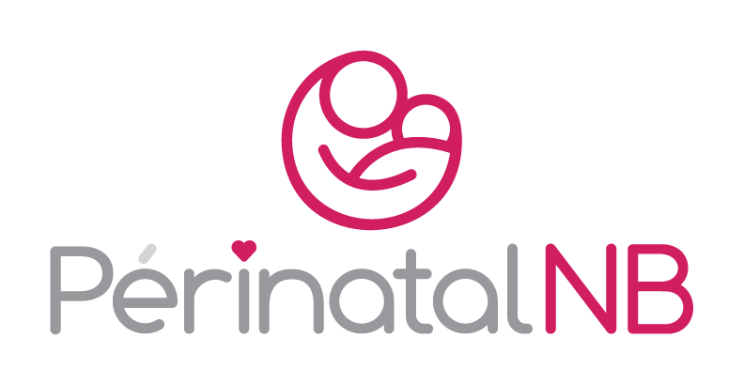

***November 20th, 2024***

***WU Conference Centre-Auditorium***

***University of New Brunswick***

***Fredericton, NB***

**2024 Perinatal Health Symposium**

**PRELIMINARY AGENDA**

8:30 – 9:00 Registration

8:55 – 9:00 Welcome

9:00 – 9:45 Keynote speaker

Dr Lynn Murphy-Kaulbeck, MD, MFM Specialist

President, Society of Obstetricians and Gynaecologists of Canada

9:45 – 10:30 The Canadian Neonatal Network/Neonatology update

Dr. Wissam, MD & Dr. Newman, MD

10:30 – 11:00 Break/refreshments

11:00 – 11:15 PerinatalNB Data Capsule

11:15 – 11:45 Vitalité Health Network Success Story: More Milk Sooner.

Julie Levasseur-Dubé, BFI Coordinator, Vitalité Health Network

Christina Gallant, BFI Coordinator, Horizon Health Network

11:45 – 12:30 Prevention of Maternal Mortality in Canada

Jocelynn L. Cook, PhD., MBA Chief Scientific Officer. Society of Obstetricians and Gynaecologists of Canada

12:30 – 13:15 Lunch

13:15 – 13:45 Horizon Health Network Success Story: The Oxytocin Toolkit

Nathalie Thompson, RN

Courtney Nelson-Ward, RN

13:45 – 14:00 PerinatalNB Data Capsule

14:00 – 14:45 NB FASD Centre of Excellence update

Dre Nicole LeBlanc, Pediatrician and Medical Director, Vitalité Health Network

14:45 – 15:15 Fredericton Midwifery Centre Success Story

TBA

15:15 – 15:30 Closing Remarks