[Text in grey italics is provided as a guide and should be deleted prior to submitting for review.]

PROTOCOL TEMPLATE
Quantitative Methods Research at Horizon

Title of Project

[Project title should be/have:
- Concise, descriptive, and fully explanatory
- A short statement that describes the main topic or variables under examination
- Worded in terms of a functional relationship that indicate independent and dependent variables.
- Key words, for indexing purposes]

Principal Investigator:
Name
Department
Institutional Affiliation
Email Address

Co-Investigator(s):
Name
Department
Institutional Affiliation
Email Address

Funding: If applicable; insert name of funding organization (e.g., NBHRF, DMNB Summer Studentship)

Version: Day, Month, Year

[Tip: Using first name, middle initial and last name reduces chances of mistaken identity, especially for publication purposes.]

[For more information about authorship and how to credit contributions in research projects, please refer to our policy, HHN-RS-010 Authorship and Acknowledgement in Research.]

PROTOCOL SUMMARY

This is a brief and comprehensive summary of the entire protocol (about ~200 words in length) and is usually the first part of your study that people will read. Do not add information that is not discussed in the protocol.

Title of Protocol

Background

This section provides the reader with the necessary context for your research problem. This information should proceed from general to more specific information related to your topic. The overarching goal is to provide a theoretical and empirical justification for your research project.

- Writing Style: Present the information in a balanced, dispassionate, and objective manner.

- Support Your Statements with Citations. Draw from the peer-reviewed literature as much as possible. Library Services at Horizon, or at your own institution, are great resources in identifying good articles for your review.

  - Try to have a very focused review that draws from the most relevant and current research (e.g., past 10 years, with emphasis on past 5 years).

  - Consider the quality of articles that you are citing.

  - If available, emphasize research syntheses, systematic reviews, or meta-analyses if available.

  - Grey literature (e.g., government reports, internal documents) are useful sources, but are not subjected to peer-review. Do not rely solely on them.

  - Avoid websites, anecdotal reports, blogs, etc.

- Citation Style: Check with your target publication or your academic program for the preferred format (e.g., APA, Vancouver)

- Use Formal Language – but Avoid Excessive Jargon. Write using formal language, clearly explain ideas, and define key words and phrases. Given that your protocol will be reviewed by institutional research ethics boards, avoid overly excessive technical jargon. Avoid slang, idiomatic expressions, and biased language.

When Writing Your Background Section, It May Help to Ask Yourself:

- Why is the topic/problem important? For example, is there a need to resolve differences in past research, extend research to new areas or populations, a neglected issue, enhancing treatment or practices, etc.?
- What research has been done on this topic already – what do we know? This does not have to describe all research done. Summarize and critically evaluate representative major arguments and conclusions and provide new insights or conceptual frameworks.
- What are the current clinical practices? Depending on the study, this can be regional, national, or international.
- How is your study different and/or how does it add to the literature and the broader body of scientific knowledge on the topic?

The background should logically progress and clearly link to the present study’s research question(s).
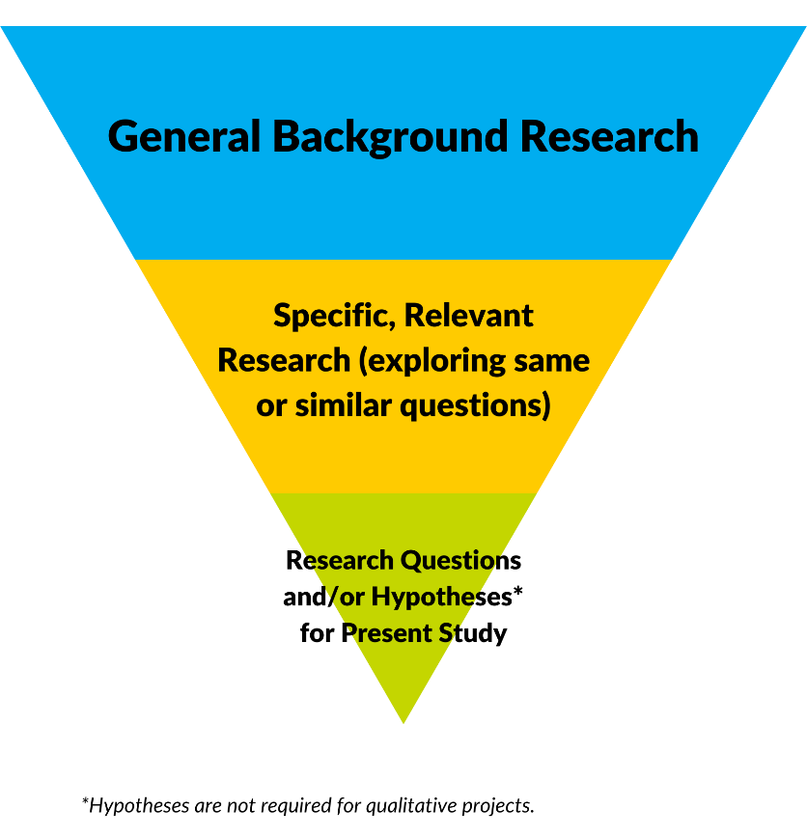
Figure 1: Flow of Information Presented in a Background Section
The Present Study

In this section, provide a concise summary of the background information, ending with the goal(s) of the present study:

Thus, the goal of the current study is to [determine / examine / evaluate / establish / identify / compare / analyze / measure / etc.] the [difference / relationship / impact / effect / etc.] of X and Y. More specifically, this will be achieved by examining the following research questions…”

Research Questions
At a minimum, a single research question is needed. Research question(s) can take many forms, but all must be fact-oriented, information-gathering questions, capable of being confirmed or refuted.

Hypotheses

Hypotheses are very specific predictive statements (e.g., “It is predicted that…”, “It is expected that…”) that indicate the anticipated nature of results.

- Link to Your Background Section. As an informed statement backed with theory, any hypotheses should link back to the information previously presented. It should be evident from reading the background how you came to your proposed hypotheses.

- Use the Right Words. Language should be included that states:
  - How groups may differ on an outcome or characteristic (i.e., greater than; less than)
  - A pattern of relationships (directionality, i.e., positive, or negative associations), or
  - A predictive relationship (i.e., X will predict Y).

- Prioritize, If Appropriate. Some studies may have primary hypotheses or questions, as well as secondary or exploratory hypotheses or questions – state this prioritization.

Hypotheses are appropriate for quantitative studies, not qualitative studies. However, note that pilot studies or descriptive studies also do not need hypotheses.

METHODS

The methods section describes how the study will be conducted. It consists of major subheadings of participants, measures/materials, procedure, and statistical analysis plan. Methods should be rich in detail to allow for evaluation of the appropriateness of the methods, to assess the reliability and validity of quantitative data, and/or trustworthiness of qualitative data, and to allow future researchers to replicate the study.

We have drafted three types of methods sections for you to choose from: quantitative studies, qualitative studies, and mixed methods designs. If you are unsure as to the best design for your research question, contact our office for consultation and support.

Example A: METHODS FOR QUANTITATIVE STUDIES

Participants

This section should provide details to allow someone reading your protocol to evaluate the appropriateness of your sample, especially important for generalizing the results. Specifically, it is good practice to:

- Include Information to Describe Your Sample (e.g., descriptive statistics). General sociodemographic, baseline, and clinical variables are appropriate so long as they are relevant to describing the sample and/or outcomes of interest.
- Population Details. If there is prior knowledge of the total potential population size from which to sample from (e.g., a patient registry, all patients with condition X at hospital, all registered pharmacists in Ontario), include this information

- Inclusion and Exclusion Criteria. List the characteristics of those who are part of your proposed sample – and, similarly, those factors that would make someone ineligible for your study.

Timeframe

This section should include the start and end dates for data collection. More specifically:

- Include the start/end dates for studies that involve active participant recruitment (e.g., cross-sectional, or prospective research; online surveys or in-person recruitment).

- For retrospective research / secondary use of data, dates ranges for the extraction should also be provided (e.g., all patients in a registry or database from 2010-2020).

Measures/Materials

This section should provide details of the materials and measures needed for the study. This includes any questionnaires, clinical or laboratory tests, and devices or mechanical apparatuses.

The selection of any measure or device should be directly informed by your literature review and research questions, i.e., there must be a clear theoretical or empirical rationale in your Background to justify its selection.

- For questionnaires, provide a clear, concise description of each proposed measure (e.g., number of items, rating scales, subscales), the key settings and parameters in which it is used, psychometric and biometric properties (i.e., reliability and validity), and scoring rules.

  - It can help to include a variable code book that lists all variables and their scales of measurement, and copies of proposed questionnaires (if there are no copyright issues).
  - If a survey was developed for the purpose of the study, should state that it’s “author-developed” the process they undertook for developing it (i.e., literature reviewed, how items were chosen, consulting with experts/patients, iterative/refinement) and if measurement properties were investigated (e.g., reliability, construct validity)
Under some circumstances, surveys can be slightly modified without invalidate them. Investigators should confirm with test developers, as altering validated surveys can substantially impact their reliability and validity.

“Altering surveys” includes:
- Changing the wording of items,
- Removing/adding items,
- Changing scoring rules,
- Changing the instructions, and/or,
- Changing timeframe.

Procedure

This section should provide details of how the study will proceed step by step from the beginning to the end in chronological order. The information below is provided as a general guide, but the sub-sections and information included will depend on the nature of the study.

Study Design

Describe your proposed study design. Is the study a cohort/case-control design, retrospective, prospective, experimental, quasi-experimental, observational, cross-sectional, or something else? Does the study have between-subjects, within-subject, or mixed-design features?

Sampling Procedures

Describe your proposed method for selecting participants.

- Will you sample…
  - Prospectively, or retrospectively (e.g., through a medical chart review)?
  - Randomly, or non-randomly (e.g., quota, purposive, convenience)?
- Where will you recruit participants from (e.g., in person, online, via chart review)?
- How will you approach potential participants?
  - Include a description of how any advertisements or letters would be used and attach copies of these documents.
- Who will approach them about the study?
  - If in a healthcare setting, are they within the circle of care?

- How will you discuss and obtain informed consent from your participants?

- Will you pay your participants?
- How will you address ethical concerns? How will you monitor for participant safety?

The age of consent in New Brunswick is 19 years. If you wish to recruit from a younger population, you will need to describe procedures to gain parental consent AND child/youth assent. Templates for both informed consent and assent are available from our office.

If you wish to obtain a waiver of consent (e.g., a retrospective chart review), please review Article 5.5A of TCPS 2 (2022) and describe how it satisfies these conditions.

Specification of the Variables under Investigation

This section does not introduce any new variables – it clarifies the roles and functions of the variables you are collecting data on.

- Which variables or the independent and dependent variables?
- Which variables are predictor or outcome variables?
- Does theory or past research point to any confounding (e.g., nuisance, noise) variables that need to be controlled?

Ensure there is a theoretical or empirical link between each variable and its inclusion in the study. This avoids casting too wide of a net, including irrelevant variables, and underpowered analyses.

Data Collection, Storage and Retention

Describe the settings and locations in which the data will be collected and securely stored, and the timing of your proposed data collection. Describe any databases you propose to use, and how information will be access and extracted.

- Does your data collection relate to any intervention that you are proposing?
- Is it a single measurement or repeated measurements?

- If manipulations or interventions will be performed:
  - Who will carry the intervention and what is their level of training?
  - How will conditions be manipulated, or interventions performed? (e.g., number of sessions or events, duration, settings, in groups or individually)

- How will the data be recorded? Will it be transposed directly from a chart to a data file?

- Are subjective ratings to be made by research assistants (if so, describing coding scheme)?

- How will data be securely transferred from one location to another?

- Who will have access to this data?

- How will this data be securely stored?

Patient-level data cannot be stored locally on personal devices, or on personal cloud-based servers (e.g., Google Drive). Alternatives include encrypted, password-protected USB keys, or institutional servers reviewed by Horizon. If you are unsure, please contact our office.

Data Quality Procedures
Describe procedures to enhance data quality, such as:

  - Matching participants for certain features (age, sex, etc.)
  - Random assignment to conditions
  - Use of multiple observations

  - Data screening / cleaning / basic check of model assumptions
  - Procedures to minimize and address missing data
  - Data reliability checks

  - Training for research assistants

  - Reliability of the observers/coders (e.g., inter-rater reliability) and established criteria for successful reliability (e.g., intraclass correlation coefficients, Kappa statistic)

Proposed Data Analysis
Statistical analysis plans are among the most important elements of a research protocol. Describe the proposed data analyses and their importance in understanding how the research question and the data/measures are linked.

It is of upmost importance that an analysis plan be specified in complete detail before collecting or analyzing any data. This avoids the ever-growing problems of p-hacking (conscious or non-conscious changing of analysis and/or methods to produce idea results, cherry-picking only significant results) or HARKing (“hypothesizing after the results are known”, aka, peeking) in research.

Even in the case of exploratory research, the details of an analysis plan should be provided.

One way to protect against p-hacking, HARKing, and related problems, is to specify your analytic plan beforehand in detail and to not deviate from it. In some cases, deviations from an approved analysis plan are unavoidable; for example, if the obtained sample is smaller than anticipated or if large amounts of missing data occur. Revised analysis plans should be treated with extreme caution, discussed with the research team and if possible, reviewed by an independent person or committee.

Assume your reader has knowledge of common statistical methods (e.g., t-tests, correlations, ANOVA models, regression models, chi-square). Uncommon methods may require some citations supporting their relevance, appropriateness, and robustness.

Include primary and secondary analyses and describe which were pre-specified or exploratory. Will any baseline, demographic, or clinical descriptive statistics be provided?

- Screening: Indicate how data will be screened for inaccuracies and statistical model assumptions.

- Variable Selection: Using theory and past research is the gold standard for guiding variable selection.
  - If alternate variable selection procedures are needed (e.g., screening variables, variables that meet certain criteria or thresholds) investigators should describe an a priori plan for selecting variables, covariates, order of entry.
  - Whenever possible, stepwise approaches to variable selection should be avoided due to several problems with these approaches which are nicely summed up here.

- Modelling: Each statistical model should include a complete description of what variable will be predictor vs outcome variable, between-subjects and within-subject factors and levels in the case of ANOVA models, and so on.

- State your alpha level (i.e., p = .05), and state whether confidence intervals (e.g., 95% or 99% confidence interval) or measures of effect size (e.g., Cohen’s d, odds ratios) will be reported.

- Alpha modifications (e.g., Bonferroni, Benjamini-Hochberg) are strongly recommended to avoid Type I error / false positive results in the case of excessive multiple comparisons.

- Underpowered Studies. If the study is inadequately powered, indicate any design elements or efforts to mitigate the lack of power and/or the potential effect on conclusions and interpretations.

  - Studies that are known to be underpowered should have an explicit disclaimer that the study is not adequately powered and to interpret results and conclusions with caution.

Sample Size and Power Analysis
Report the intended sample size and how this sample size was determined a priori (i.e., using a power analysis before you begin the study).

Although pilot studies and descriptive studies do not necessarily require power analyses, there should be some consideration or underlying rationale for the chosen sample size.

If a power analysis is performed, include all input parameters so that it can be evaluated in its entirety and replicated. You can use calculators to help, such as G*Power.

- If the study has different conditions or groups for comparison, report the intended sub-sample sizes.
- If you have several types of analyses, provide details for all power analyses, then summarise a final required sample based on the one that needs the largest number of participants.
- Cite the source/rationale for the effect sizes you have chosen to calculate your power and sample size.

- If the power analysis suggests a sample that is larger than what can be obtained (i.e., underpowered analyses), what is your plan to mitigate this? For example:
  - Will you modify the study design (e.g., go from an inferential study descriptive study)?

  - Will you simplify the proposed analytic models (i.e., less variables, fewer timepoints)?

  - Will you increase the recruitment window and/or include more sites to increase sample size?

  - Or, if nothing can be done, what is the plan to interpret conclusions within the context of underpowered analyses?

The most appropriate analysis is often the simplest analysis that is related to the study design and that will most effectively answer the research question.

Conclusion

The protocol should conclude with a short summary of the purpose of the project, what is hoped to achieve, how this will benefit the population (patients and/or staff) of Horizon Health Network, and its potential implications for theory, research, and practice.

References

Provide a complete list of references. There are many types of referencing styles (e.g., APA style, Vancouver style) to choose from. Select one style and use it consistently.

Appendices

Common appendices included in research protocols include documents such as:

- Glossary of abbreviations

- Surveys, case report forms or any other documents used with participants to collect data

- Data collection and management codebooks

- Informed consent documents

- Study budget

- Knowledge translation plan

- Debriefing letters or handouts to participants

- Advertisements or recruiting materials

- Translated versions of pertinent information in other languages

This is not an exhaustive list. If you have any questions about whether something should be included for review, please contact Research Services.

Contact our office for a data codebook template.

