[Text in grey italics is provided as a guide and should be deleted prior to submitting for review.]

PROTOCOL TEMPLATE
Qualitative Methods Research at Horizon

Title of Project

[Project title should be/have:
- Concise, descriptive, and fully explanatory
- A short statement that describes the main topic or variables under examination
- Worded in terms of a functional relationship that indicate independent and dependent variables.
- Key words, for indexing purposes]

Principal Investigator:
Name
Department
Institutional Affiliation
Email Address

Co-Investigator(s):
Name
Department
Institutional Affiliation
Email Address

Funding: If applicable; insert name of funding organization (e.g., NBHRF, DMNB Summer Studentship)

Version: Day, Month, Year

[Tip: Using first name, middle initial and last name reduces chances of mistaken identity, especially for publication purposes.]

[For more information about authorship and how to credit contributions in research projects, please refer to our policy, HHN-RS-010 Authorship and Acknowledgement in Research.]

PROTOCOL SUMMARY

This is a brief and comprehensive summary of the entire protocol (about ~200 words in length) and is usually the first part of your study that people will read. Do not add information that is not discussed in the protocol.

Title of Protocol

This section provides the reader with the necessary context for your research problem. This information should proceed from general to more specific information related to your topic. The overarching goal is to provide a theoretical and empirical justification for your research project.

- Writing Style: Present the information in a balanced, dispassionate, and objective manner.

- Support Your Statements with Citations. Draw from the peer-reviewed literature as much as possible. Library Services at Horizon, or at your own institution, are great resources in identifying good articles for your review.

  - Try to have a very focused review that draws from the most relevant and current research (e.g., past 10 years, with emphasis on past 5 years).

  - Consider the quality of articles that you are citing.

  - If available, emphasize research syntheses, systematic reviews, or meta-analyses if available.

  - Grey literature (e.g., government reports, internal documents) are useful sources, but are not subjected to peer-review. Do not rely solely on them.

  - Avoid websites, anecdotal reports, blogs, etc.

- Citation Style: Check with your target publication or your academic program for the preferred format (e.g., APA, Vancouver)

- Use Formal Language – but Avoid Excessive Jargon. Write using formal language, clearly explain ideas, and define key words and phrases. Given that your protocol will be reviewed by institutional research ethics boards, avoid overly excessive technical jargon. Avoid slang, idiomatic expressions, and biased language.

When Writing Your Background Section, It May Help to Ask Yourself:

- Why is the topic/problem important? For example, is there a need to resolve differences in past research, extend research to new areas or populations, a neglected issue, enhancing treatment or practices, etc.?
- What research has been done on this topic already – what do we know? This does not have to describe all research done. Summarize and critically evaluate representative major arguments and conclusions and provide new insights or conceptual frameworks.
- What are the current clinical practices? Depending on the study, this can be regional, national, or international.
- How is your study different and/or how does it add to the literature and the broader body of scientific knowledge on the topic?

The background should logically progress and clearly link to the present study’s research question(s).
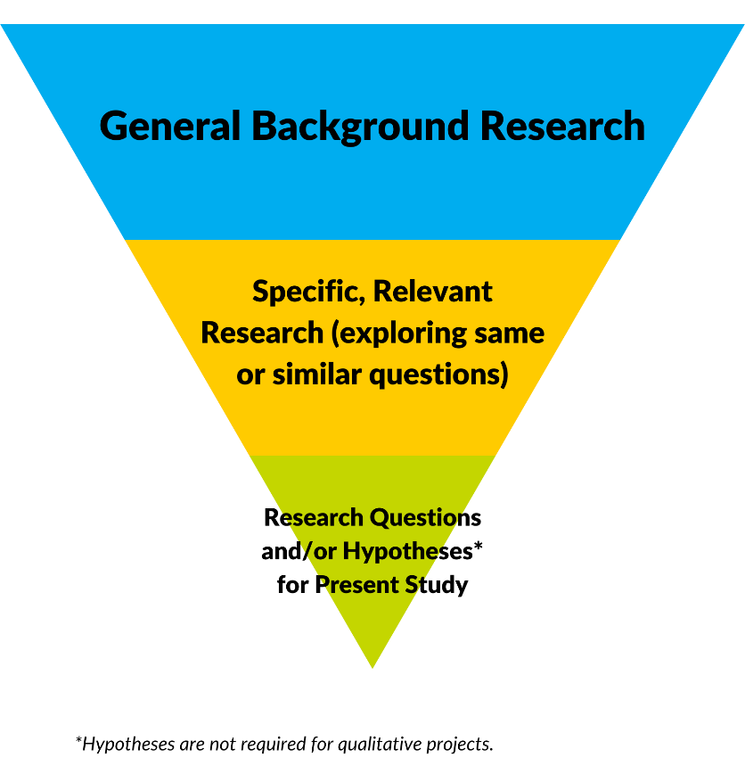
Figure 1: Flow of Information Presented in a Background Section
The Present Study

In this section, provide a concise summary of the background information.

For qualitative research, it is not the norm to have hypotheses (i.e., using hypotheses in a qualitative study would need to be justified). Rather, you would present the purpose/aim of the study, and general research questions (which can often take the form of more general statements of “goals”).

Present the purpose and research questions in neutral language that does not indicate how you think people may respond (i.e., a particular “direction” of response).

METHODS

Study Design
What design does the proposed study use? Examples of qualitative research designs, which includes theoretical frameworks and/or methodological approaches, include:
- Content analysis
- Grounded theory
- Phenomenology
- Participatory action research
- Narrative inquiry
- Case studies

Sample
Participants
Describe the proposed sample, and inclusion and exclusion criteria. Who is included, and who is excluded from participation?

Power analyses are not necessary for qualitative projects.

Considerations for determining a sample size are not the same as those for quantitative research studies. Please note that you are expected to give an estimated sample size and justification for it.

For more discussion on this topic, see the below article which discusses the concept of saturation within qualitative research, the debates around it, and the different ways in which it is used.

Saunders, B., Sim, J., Kingstone, T. et al. Saturation in qualitative research: exploring its conceptualization and operationalization. Qual Quant 52, 1893–1907 (2018). https://doi.org/10/1007/s11135-017-0574-8

Sampling Technique
How will you recruit participants to your study? Include details about the specific sampling technique (for example: convenience and snowball sampling) you will use in your study, and your rationale for selecting this method.

Procedure
This section should provide details of how the study will proceed step by step from the beginning to the end in chronological order. The information below is provided as a general guide, but the information included will depend on the nature of the study. Include some information related to the following sub-sections:

Like a quantitative procedure section, summarize the details of your recruitment and engagement with participants, data collection, and follow-up procedures. Some points to consider that are unique to qualitative research procedure:

- How will the qualitative data be collected (e.g., interviews (specify the type), focus groups, questionnaires, observation, document analysis)?
  - Who will collect the data?
  - Will there be training for these data collectors?
  - What is the experience level of those conducting the collection?
  - What materials do you need to collect the data?
    - If you are creating new materials, such as a semi-structured interview guide, how did you develop these materials?
  - Include guides for any data collection methods such as interviews, focus groups, and observations in appendices to the protocol. Any questionnaires used would also be included in the appendices.

- Where will data collection take place? For example: in-person (at a location of the participants’ choosing, or a set location, such as an office), via telephone, via online videoconference software (describe the privacy protection of the software), or multiple locations and means (specify).

- How will the qualitative data be recorded?
  - How will it be transcribed (e.g., verbatim?) and who will do this task?
  - Where will the transcripts, notes, video or audio recordings, and any other data traces be stored?
  - Will the transcripts require translation?
  - Are there other steps needed to prepare the data for analysis?

Please describe the settings and locations in which the data will be collected and securely stored.

- How participants will be recruited (e.g., in person, online, via chart review)?
  - For chart reviews, describe the database and how information will be access and extracted.

- How will the data be recorded? Will it be transposed directly from a chart to a data file? Are subjective ratings to be made by research assistants (if so, describing coding scheme)? How will interview data be handled?

- How will data be securely transferred from one location to another?

Patient-level data cannot be stored locally on personal devices, or on personal cloud-based servers (e.g., Google Drive). Alternatives include encrypted, password-protected USB keys, or institutional servers reviewed by Horizon. If you are unsure, please contact our office.

While field notes are helpful, it is essential and best practice to audio and/or video record your conversations with participants. If you do not follow this best practice, you would need to include justification as to why recordings are not being used. There are some cases (e.g., with vulnerable populations) where one may not use recordings, so it is possible but would need justification.

Qualitative Analysis Plan
Describe the proposed data analyses and their importance in understanding how the research question and the data/measures are linked.

- What type of analysis will you conduct on the qualitative data? Is it inductive or deductive? Cite sources for your analysis. Examples of analyses include, but are not limited to:
  - Thematic analysis
  - Discourse analysis
  - Narrative analysis
  - Constant comparative analysis
  - Interpretative phenomenological analysis
  - Conversation analysis

The most appropriate analysis is often the simplest analysis that is related to the study design and that will most effectively answer the research question.

- How will any notes you take be used in your analysis?

Be sure to include details about any software used, and the management of any identifying details that are present in the conversations/transcripts. Best practice is deidentification to manage identifying details.

State who on the research team will be conducting the analysis. If a team analysis approach is being used, please describe what process will be used and how the final analysis will be decided.

Describe how you will demonstrate the quality of your data and analysis. Creswell (1998) proposes eight strategies, with a recommendation that you use at least two:
- Member/participant-checking
If using participant-checking, please detail:
  - At what point of data collection and/or analysis this is taking place.
  - What is being returned for participant input (e.g., their transcript and/or the finished analysis of the project).
  - What means are being used to get participant input (e.g., email, mail, etc.).
  - How participant input will be incorporated.
- Clarification of researcher bias (reflexivity)
- Peer review or debriefing
Please note that peer review would need to keep in mind that access to the research project
data is restricted to the research team.
- Triangulation
- Rich, thick description

- Prolonged engagement and persistent observation
- Negative case analysis

- External audits

Conclusion

The protocol should conclude with a short summary of the purpose of the project, what is hoped to achieve, how this will benefit the population (patients and/or staff) of Horizon Health Network, and its potential implications for theory, research, and practice.

References

Provide a complete list of references. There are many types of referencing styles (e.g., APA style, Vancouver style) to choose from. Select one style and use it consistently.

Appendices

Common appendices included in research protocols include documents such as:

- Glossary of abbreviations

- Surveys, interview guides or any other documents used with participants to collect data

- Data collection and management codebooks

- Informed consent documents

- Study budget

- Knowledge translation plan

- Debriefing letters or handouts to participants

- Advertisements or recruiting materials

- Translated versions of pertinent information in other languages

This is not an exhaustive list. If you have any questions about whether something should be included for review, please contact Research Services.

