PROTOCOL GUIDANCE
Mixed Methods Research at Horizon

For mixed methods designs, you will need to refer to both the Quantitative Research and the Qualitative Research Protocol templates available on Skyline. The description of a mixed-methods study will include the appropriate elements from quantitative and qualitative methodologies, as described in the earlier sections, with respect to Participants, Materials and Procedure.

How will you mix quantitative and qualitative data? It is important to identify your Study Design, as it has implications for interpreting your Qualitative Analysis section.

Examples of mixed methods designs include triangulation, explanatory, exploratory and nested or embedded designs. For more information, contact our office to schedule a consultation.

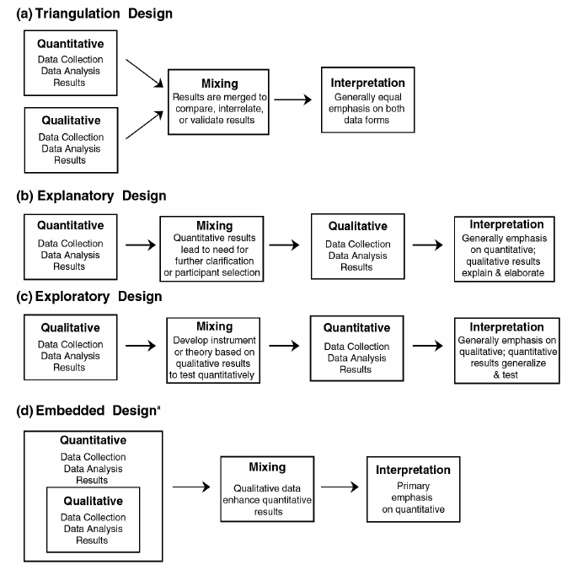

Figure 2: Creswell JW & Plano-Clark VL. (2007). Designing and conducting mixed methods research. Thousand Oaks, Calif: SAGE Publications.

