[Text in grey italics is provided as a guide and should be deleted prior to submitting for review.]

Office of Research Services
Research Protocol Template

Office of Research Services
Hilyard Place, Suite A-200
560 Main Street
Saint John, New Brunswick, Canada E2K 1J5
Tel (506) 648-6090 Fax (506) 648-6173

Title of Project

[Project title should be/have:
- Concise, descriptive, and fully explanatory
- A short statement that describes the main topic or variables under examination
- Worded in terms of a functional relationship that indicate independent and dependent variables.
- Key words, for indexing purposes]

Principal Investigator:
Name
Department
Institutional Affiliation
Email Address

Co-Investigator(s):
Name
Department
Institutional Affiliation
Email Address

[Tip: Using first name, middle initial and last name reduces chances of mistaken identity, especially for publication purposes.]

[For more information about authorship and how to credit contributions in research projects, please refer to our policy, HHN-RS-010 Authorship and Acknowledgement in Research.]

PROTOCOL SUMMARY

This is a brief and comprehensive summary of the entire protocol (about ~200 words in length) and is usually the first part of your study that people will read. Do not add information that is not discussed in the protocol.

OR, IF PREPARING A MANUSCRIPT FOR PUBLICATION, USE:

ABSTRACT

Similar to the summary, this is brief and comprehensive. Word count varies depending on the publication.

A good abstract should consist of the main highlights of your protocol with respect to the problem under investigation, sample characteristics, essential features of your study’s method, most important findings, and conclusion/implications. Do not add information that is not discussed in the protocol, but ensure it includes essential information – abstracts are indexed in search databases and is usually the first part of your study that people will read when doing a literature search.

Title of Protocol

Background
This section provides the reader with the necessary context for your research problem. This information should be proceed from general to more specific information related to your topic. The overarching goal is to provide a theoretical and empirical justification for your research project.

Present the information in a balanced, dispassionate, and objective manner. Support your statements with citations – check your target publication or your academic program for the preferred format (e.g., APA, Vancouver)

Draw from the peer-reviewed literature as much as possible. Grey literature (e.g., government reports, internal documents) are useful sources, but are not subjected to peer-review. Avoid websites, anecdotal reports, blogs, etc. Emphasize research syntheses, systematic reviews, or meta-analyses if available.

Consider the quality of articles that you are citing. Try to have a very focused review that draws from the most relevant and current research (e.g., past 10 years, with emphasis on past 5 years). Library Services at Horizon, or at your own institution, are great resources in identifying good articles for your review.

Given that your proposal will be reviewed by institutional research ethics boards, avoid overly excessive technical jargon. Write using formal language, clearly explain ideas, and define key words and phrases. Avoid slang, idiomatic expressions, and biased language.

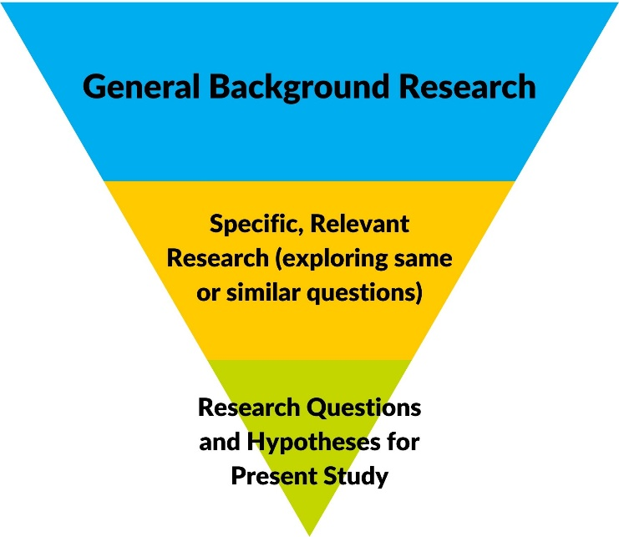

When Writing Your Background Section, It May Help to Ask Yourself:

- Why is the topic/problem important? For example, is there a need to resolve differences in past research, extend research to new areas or populations, a neglected issue, enhancing treatment or practices, etc.?

- What research has been done on this topic already – what do we know? This does not have to describe all research ever done: summarize and critically evaluate representative major arguments and conclusions, and provide new insights or conceptual frameworks.

- What are the current clinical practices? Depending on the study, this can be regional, national or international.

- How is your study different and/or how does it add to the literature and the broader body of scientific knowledge on the topic?

The Present Study
[The background should logically progress to the study’s research question(s). There must be a clear link between the literature reviewed and the stated research questions. They must be fact-oriented, information-gathering questions, capable of being confirmed or refuted. Research question(s) can take many forms and are often followed up by more specifically defined objectives and aims. At a minimum, a single research question is needed.]

Research Questions
Below is a schematic of a research question that leads to more specific research objective:

- “The goal of the current study is to [determine / examine / evaluate / establish / identify / compare / analyze / measure / etc] the [difference / relationship / impact / effect / etc] of X and Y. More specifically, this will be achieved by …”

Hypotheses
Not all projects (e.g., qualitative projects) have hypotheses, but it is highly recommended to include them. Hypotheses are very specific predictive statements (e.g., “It is predicted that…”, “It is expected that…”) that indicate the anticipated nature of results.

- Language should be included that state how groups may differ on an outcome or characteristic (i.e., greater than; less than), patterns of relationships (directionality; i.e., positive or negative associations), or a predictive relationship (i.e., X will predict Y).

- Some studies may have primary hypotheses or questions, as well as secondary or exploratory hypotheses or questions – state this prioritization.

Methods

The methods section describes how the study will be conducted. It consists of major subheadings of participants, measures/materials, procedure, and statistical analysis plan. Methods should be rich in detail in order to allow for evaluation of the appropriateness of the methods, to assess the reliability and validity of the results, and to allow future researchers to replicate the study. Be sure to include sufficient information so that your readers are able to replicate your experiments or interventions.
Participants
This section should provide details to allow examination of the appropriateness of your sample, particularly for generalizing the results. If there is prior knowledge of the total potential population size from which to sample from (e.g., a patient registry, all patients with condition X at hospital, all registered pharmacists in Ontario), include this information.

It is good practice to include information to describe your sample (e.g., descriptive statistics). General sociodemographic, baseline, and clinical variables are appropriate so long as they are relevant to describing the sample and/or outcomes of interest. Also include study inclusion and exclusion criteria.

Measures/Materials
This section should provide details of the materials and measures needed for the study. Common examples include questionnaires and clinical / mechanical apparatuses.

Include a clear but concise description of the questionnaires (e.g., number of items, rating scales, subscales) instruments, key settings and parameters, and scoring rules. Include information regarding their psychometric and biometric properties (i.e., reliability and validity).

Importantly, the selection of any measure/material should be directly informed by the research questions and background literature review; if a measure is included, there must be a theoretical or empirical rationale in the study background section to justify its inclusion.

Procedure
This section should provide details of how the study will proceed step by step from the beginning to the end in chronological order. The information below is provided as a general guide, but the information included will depend on the nature of the study. Include some information related to the following sub-sections:

Study design
- Is the study a cohort/case-control, retrospective, prospective, experimental, quasi-experimental, observational, cross-sectional, or something else?
- Does the study have between-subjects, within-subject, or mixed-design features?

Sampling procedures
- Method for selecting participants. For example, random sampling vs non-random sampling (e.g., quota, purposive, convenience) approaches.
- Payments to participants, how potential ethical concerns will be addressed, and safety monitoring procedures.

Specification of the variables under investigation
- Which variables or the independent and dependent variables?
- Which variables are predictor or outcome variables?
- Does theory or past research point to any confounding (e.g., nuisance, noise) variables that need to be controlled?
- As mentioned previously ensure there is a theoretical or empirical link between each variable and its inclusion in the study. This avoids casting too wide of a net, including irrelevant variables, and underpowered analyses.

Data collection
- Settings and locations in which the data will be collected and securely stored.
- How will data be securely transferred from one location to another
- How participants will be recruited (e.g., in person, online, via chart review)
- For chart reviews, describe the database and how information will be access and extracted.
- How will the data be recorded? Will it be transposed directly from a chart to a data file? Are subjective ratings to be made by research assistants (if so, describing coding scheme)? How will interview data be handled?

If manipulations or interventions will be performed
- Who will carry the intervention and what is their level of training?
- How will conditions be manipulated or interventions performed? e.g., number of sessions or events, duration, settings, in groups or individually

Describe procedures to enhance data quality
- Training for research assistants
- Reliability of the observers/coders (e.g., inter-rater reliability) and established criteria for successful reliability (e.g., intraclass correlation coefficients, Kappa statistic)
- Use of multiple observations.
- Data reliability checks

Systematic reviews or meta-analyses
- Please note that guidance of systematic reviews and meta-analyses is beyond the scope of this protocol template. Given the importance of systematic reviews and meta-analyses in synthesizing bodies of research, the Preferred Reporting Items for Systematic Reviews and Meta-Analyses (PRISMA) guidelines should be followed (www.prisma-statement.org). Peer-reviewers and funders are increasingly adopting PRISMA (or similar) reporting standards guidelines to assess the completeness and transparency of a systematic review or meta-analysis.

Data Analysis Plan
Describe the proposed data analyses and their importance in understanding how the research question and the data/measures are linked. The most appropriate analysis is often the simplest analysis (quantitative or qualitative) that is related to the study design and that will most effectively answer the research question. Include primary and secondary analyses, and describe which were pre-specified or exploratory.

Research studies/questions can be exploratory in nature, but an analysis plan should always be pre-specified. Even with exploratory research, there is always a plan of which variables to analyze and which tests to use.

- Indicate how data will be screen for inaccuracies and statistical model assumptions.
- Will any baseline, demographic, or clinical descriptive statistics be provided?
- Assume your reader has knowledge of common statistical method (e.g., t-tests, correlations, ANOVA models, regression models, chi-square). Uncommon methods may require some citations supporting their relevance, appropriateness, and robustness
- Each statistical model should include a complete description of what variable will be predictor vs outcome variable, between-subjects and within-subject factors and levels in the case of ANOVA models, and so on.
- For certain analysis such as hierarchical regression, past theory and research should be used to justify variable selection and order of variable entry.
- State your alpha level (i.e., p = .05; or justify any modifications such as Bonferroni or Benjamini-Hochberg corrections), and state whether confidence intervals (e.g., 95% or 99% confidence interval) or measures of effect size (e.g., Cohen’s d, odds ratios) will be reported.
- For qualitative research describe how you will recruit participants and collect information. type of qualitative analysis, how the analysis will be conducted (e.g., on NVIVO), etc.

Sample size: Report the intended sample size and how this sample size was determined (e.g., power analysis, published sample size recommendations). You can use power calculators to help, such as gpower (http://www.psychologie.hhu.de/arbeitsgruppen/allgemeine-psychologie-und-arbeitspsychologie/gpower.html)

If the study has different conditions or groups for comparison, report the intended sub-sample sizes. If a power analysis is performed, include all input parameters so that it can be evaluated in its entirely and replicated. If the study is inadequately powered, indicate any design elements or efforts to mitigate the lack of power and/or the potential effect on conclusions and interpretations. Studies that are known to be underpowered should have an explicit disclaimer that the study is not adequately powered and that to interpret results and conclusions with caution. Power analyses are not necessary for qualitative projects.

Note: Statistical analysis plans are among the most important elements of a research protocol. It is of upmost importance that an analysis plan be specified in complete detail before collecting or analyzing any data. This avoids the ever-growing problems of p-hacking (conscious or non-conscious changing of analysis and/or methods to produce idea results, cherry-picking only significant results) or HARKing (“hypothesizing after the results are known”, aka, peeking) in research. Even in the case of exploratory research, the details of an analysis plan should be provided. One way to protect against p-hacking, HARKing, and related problems, is to specify your analytic plan beforehand in detail and to not deviate from it. In some cases, deviations from an approved analysis plan are unavoidable; for example, if the obtained sample is smaller than anticipated or if large amounts of missing data occur. Revised analysis plans should be treated with extreme caution, discussed with the research team and if possible, reviewed by an independent person or committee.

Conclusion

The protocol should conclude with a short summary of the purpose of the project, what is hoped to achieve, how this will benefit the population (patients and/or staff) of Horizon Health Network, and its potential implications for theory, research and practice.

References

Provide a complete list of references. There are many types of referencing styles (e.g., APA style, Vancouver style) to choose from. Select one style and use it consistently.

Appendices

Common appendices included in research protocols include documents such as:

- Glossary of abbreviations;
- Surveys, case report forms or any other documents used with participants to collect data;
- Data collection and management codebooks;
- Informed consent documents;
- Study budget;
- Knowledge translation plan;
- Debriefing letters or handouts to participants;

This is not an exhaustive list. If you have any questions about whether something should be included for review, please contact Research Services.

