The Stan Cassidy Centre for Rehabilitation Paediatric Neuro-Motor Team
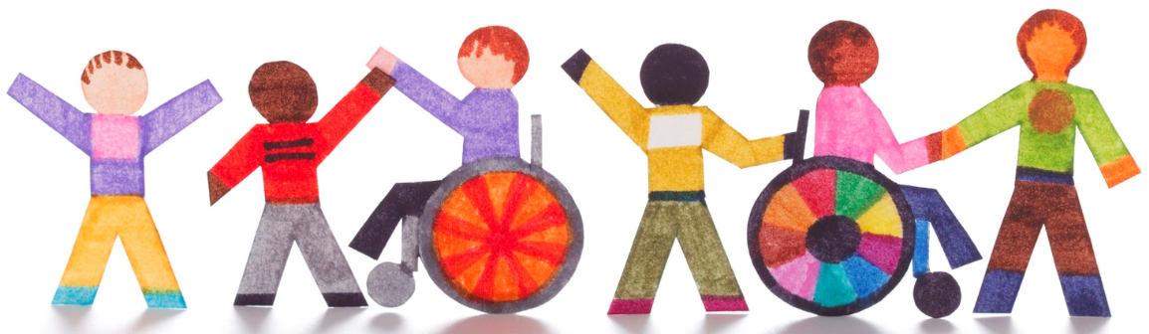
1) Who are we?
- Our team specializes in tertiary peadiatric rehabilitation. Our goal is to help children maximize their potential. We work as a team, alongside your family to find effective and practical solutions to meet your child’s unique needs.

2) Who do we help?
- We offer service to children who have neurological impairments such as spinal cord and brain injury, Cerebral Palsy, Muscular Dystrophy, and children with genetic syndromes. We work with children until they reach late adolescence.

3) How do we provide service?
- We have a provincial mandate to serve children and their families with neurological impairments in the province of New Brunswick. Service to our clients is provided in their language of choice (French or English). We do not carry a caseload of our own; rather we provide assistance to caregivers, rehabilitation providers and teachers who are working with these children on a regular basis.
- Services may include short stays at the Stan Cassidy Centre for Rehabilitation. These can range from a half-day to several weeks in duration depending on your child’s needs. We also do outreach visits to schools and homes around the province.

4) How can we help?
- We can provide consultation, assessment, education, equipment, and training. We offer in-depth, team based assessment services such, program development or review, spasticity (muscle tightness) management, and feeding and swallowing evaluation. Your child may be seen by multiple programs at the same time.


What our team members do:

Physiatrists (Rehabilitation Doctor)
- Evaluates the medical, functional and psychosocial condition of your child, and how it may be affecting your family.
- Provides information regarding the diagnosis and disease process.
- Discusses the best treatment options and plans available with your family.

Nurse Clinic Coordinator
- Organizes the pre-clinic process.
- Helps your family and healthcare professionals communicate.
- Provides information and follow up on medical management.

Physiotherapists
- Works with you and your child to help with mobility goals through movement, exercise, education and advice.
- They also provide information and education regarding leg braces and equipment, such as walkers and standers.

Occupational Therapists
- Works with you and your child to promote participation and safety during daily activities. They can work on leisure pursuits, and to help your child become more active as a student, friend and volunteer.

Speech Language Pathologist
- Works with you and your child to assist in the identification of speech, language and swallowing disorders.
- Provides recommendations to: promote continued independence, maintain present skills, and create adaptive strategies to help your child communicate.

Dietetics
- Works with you and your child to assess height, weight and what your child eats, or ingests via feeding tube on a daily basis.
- Will help you make plans to meet your child’s unique nutritional needs.

Social Work
- Focuses on the psychosocial needs of your family. Provides assessment, education, advocacy, and support to you and your family, as well as information about resources and services in the community.

Rehabilitation Assistants
- Assists physiotherapists, occupational therapists, and speech language pathologists to help meet your child’s needs. Provides company and support for your child in-between appointments when necessary.

Administrative Assistants & Resource & Scheduling Coordinators
- Provide administrative support to the team. Is also a center-wide resource and point of contact for families, patients and local therapists from across the province of New Brunswick.
- Oversees the coordination of all appointments, several specialized clinics, outreach visits, Telehealth services and many other scheduling related appointments.
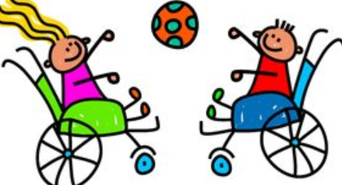
6) Other Stan Cassidy Centre for Rehabilitation Centre Services include (depending on your child’s needs they may also receive a coordinated appointment with:)

Education Liaison
- Works with you and your child to identify any educational concerns they may be experiencing.
- Acts as a liaison between your family and your child’s school to help ensure your child’s specific needs are being met.

Adaptive Seating Department
- This service is made up of occupational therapists and the rehabilitation engineers who work with you and your child to evaluate and form solutions for your child’s individual seating and mobility needs.

Augmentative Communication Service
- This service is made up of occupational therapists and rehabilitation engineers who work with you and your child to promote greater independence through assistive technology and custom adaptations (use of computers, phones, games, toys etc.)

Recreational Therapy
- This service is made up of a recreational therapist and rehabilitation assistants who work with you and your child to facilitate and optimize full participation in life through leisure and recreation.

Respiratory Therapy
- This service is made up of a respiratory therapist who will work with you and your child to evaluate, treat, and maintain cardiopulmonary (heart and lung) function.

7) Who can I contact with questions or concerns?

Clinical Facilitator Paediatric Team Manager Scheduling Clerk
Krista Fraser Sarah Lavoie Jacqueline Moore
(506) 452-5427 (506) 452-5230 (506) 452-5772



