Spasticity Management Program Frequently Asked Questions

- What is Spasticity Management?
- The Spasticity Management Clinic provides services and support to children and their families affected by Cerebral Palsy or other conditions that can contribute to spastic (very tight) muscles.

- What can I expect at a Spasticity Management Appointment?
- A visit may include appointments with a Physiatrist (the Doctor), Physical Therapist(s), Occupational Therapist(s), and Rehabilitation Assistant(s).
- You and your child will be assigned a room where the Physiatrist/therapists will come to assess your child and provide treatment options, equipment, referrals to other specialists and/or links to community resources. Typical appointments are between 2-3 hours in length.
- Be prepared to answer many questions about your child’s daily routine, habits and current abilities. You will be asked about your priorities and goals for your child. Therapists will assess your child using hands-on techniques and through observation.

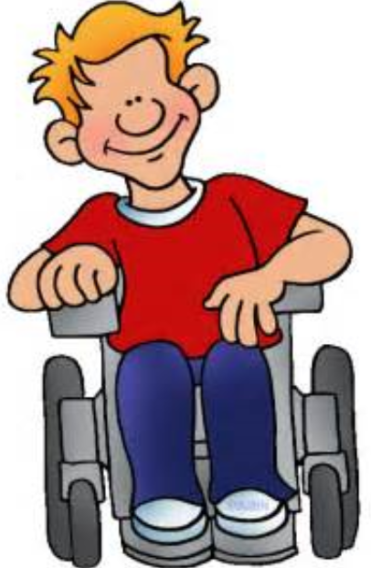

- Your child’s gait (how they walk) may be analyzed by watching them walk with and without their orthotics/braces on (if they have them). Tightness is usually measured by moving a child’s arm or leg quickly through their range of motion. It is measured with an angle measurer called a goniometer.
- Your child may be asked to participate in other activities that can help determine how their muscle tightness influences their daily life.

- Who should attend the appointment?
- Typically, children and a parent(s)/guardian(s) attend the appointment. However, if you have other children or family members (such as grandparents) who support your child they are welcome to attend.

- What is BOTOX?
- Botox is short for Botulinum Toxin A, which is sometimes injected into a child’s muscles in order to temporarily reduce tightness/spasticity. Whether or not BOTOX is right for you and your child will be a discussion that you and the Physiatrist (Doctor) will have.

- What should I bring to my child’s appointment?
- Please bring your valid Medicare card and proof of any other medical coverage that your child has such as private insurance (ex: Blue Cross, Johnsons) or a Department of Social Development Health Card.
- Please bring shorts and sneakers.
- Please bring an updated list of the medical professionals currently involved in your child’s care, as well as a list of current medications and dosing schedule.
- Please bring any necessary medical equipment (i.e. tube feeding supplies, oxygen, orthotics, splints, communication devices, etc.).

- Will my child undergo any medical tests at Spasticity Management clinic?
- You may be sent with your child to the connected Dr.Everett Chalmer’s Hospital for x-rays. Therapists and the Physiatrist may use their hands to test and measure your child’s strength and flexibility. Otherwise, most tests are arranged separately and are often done in your community.
- Will there be Follow-up?
- There is a possibility that follow-up appointments will be scheduled for BOTOX injections (in the office or at the hospital), serial casting (locally or here at the SCCR), orthotics referrals (locally or here at the SCCR), and/or other interventions (taping, treatment, stretches, etc).

- Where do I park when I attend the Spasticity Management clinic?
- There is parking available in front of the Stan Cassidy Centre for Rehabilitation for any families who have a wheelchair-parking placard. Parking is also available in the paid parking lot in front of the Dr. Everett Chalmers Hospital.

- Whom should I contact with questions/concerns?
- If you have any questions/concerns please do not hesitate to contact us at:

Paediatric Team Manager Scheduling Clerk Marie-Elaine Beaulieu
Sarah Lavoie Jacqueline Moore Physiotherapist
(506) 452-5230 (506) 452-5772 (506) 447-4047

