Le Centre de Réadaptation Stan Cassidy Centre for Rehabilitation
800 rue Priestman St., Fredericton, NB E3B 0C7
Tel / Tél: (506) 452-5225
FAX / Téléc: (506) 447-4749
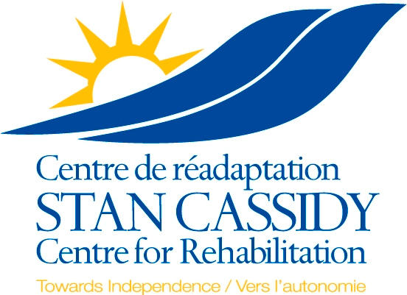

SCCR Consultation Request Requirements and Criteria for referrals of adolescents and adults

The Stan Cassidy Centre for Rehabilitation is New Brunswick’s provincial neuro-rehabilitation centre serving patients and their families affected by neurotrauma, neurological disorders and lifespan neurological conditions. The centre provides inpatient, outpatient, outreach, and telehealth services, and supports a strong research, education, and training program.

The centre has dedicated clinical teams, and for most services other than Driving and Seating Services, all patients managed by the rehabilitation teams must be under the care of one of the SCCR physiatrists. All referrals are reviewed weekly. If appropriate, the SCCR physiatrists triage the referral and determine if the patient will be seen in a specialty clinic or office assessment, which other resources and team members will be involved, the urgency of the assessment, and/or if further information is required. A letter indicating such will be faxed back to the referral source. If there are any concerns the referring practitioner is welcome to call us to discuss.

REFERRAL REQUIREMENTS: A letter of referral must be written by a physician or nurse practitioner, and must include:

1. Patient demographics including contact information
2. Diagnosis
3. Date of Onset (if applicable)
4. Specific reason for SCCR referral
5. Relevant associated history
6. Copies of relevant consultation or investigation reports not available in the NB Electronic Health Record

The provincial neurorehabilitation centre treats the following adult and adolescent conditions:

- MS EDSS 5.0 and above
- ALS and other motor neuron diseases
- Muscular Dystrophies, Cerebellar/Spinal ataxias
- Spinal cord injury
- Guillain Barre Syndrome
- Brain tumors with neurological deficit
- Traumatic Brain Injury (Moderate and Severe)
- Complex polyneuropathy
- Spina bifida
- Cerebral Palsy
- *Upper limb amputation (seen with the UNB Atlantic Clinic for Upper Limb Prosthetics)
- Complex stroke only with referral and discussion of regional physiatrists

We do not accept referrals for musculoskeletal conditions, concussion, headache, epilepsy, lower limb amputations, dementia, chronic pain, developmental delay, or mental health diagnoses. Persons with Stroke should be referred to regional/local hospitals and/or rehabilitation services.

For referrals to our Paediatric Neuromotor or Autism team, Seating Department, and Driving Rehabilitation services please use the referral forms located at https://horizonnb.ca/horizon-services/provincial-program/stan-cassidy-centre-for-rehabilitation/

Inpatients: Patients currently hospitalized who are being referred for possible inpatient admission/transfer:
the referring physician/nurse practitioner must call 506-452-5355 and ask to speak to the physiatrist on call for an inpatient referral. No patient is considered without direct contact from the referring physician.

